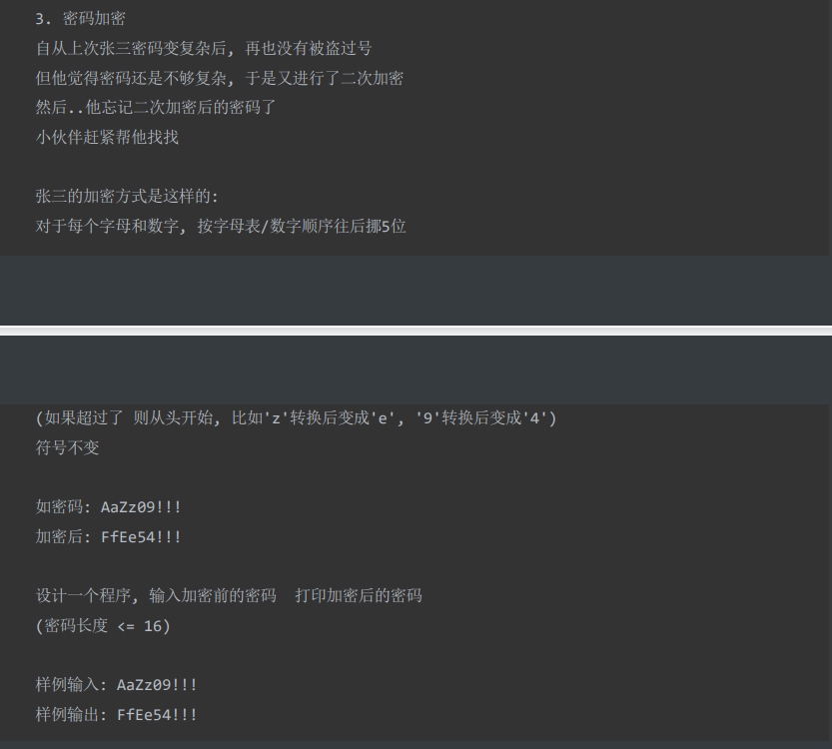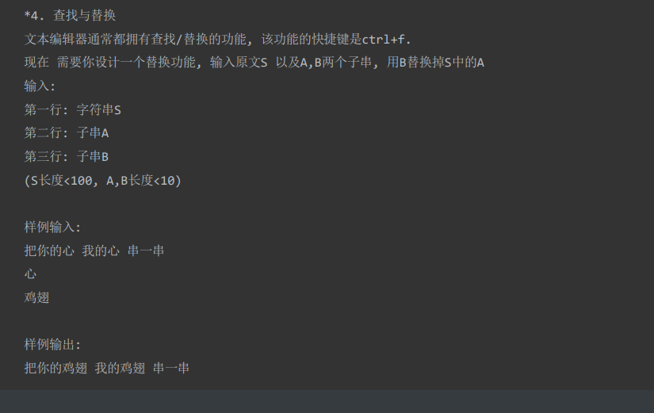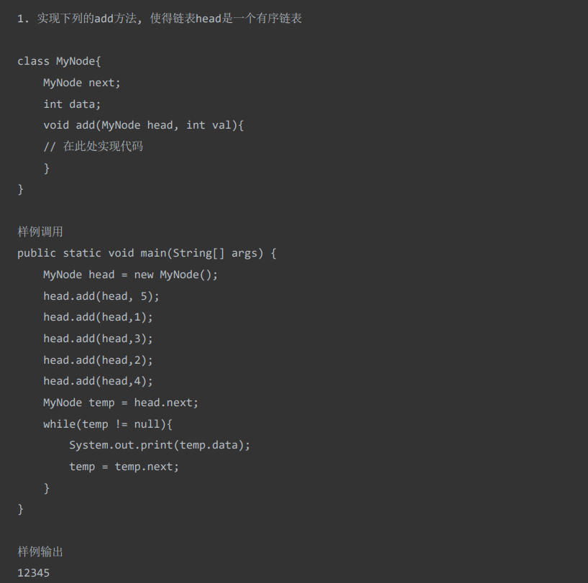
样例调用
Public static void main(String[] args){
MyNode head = new MyNode();
head.add(head, 5);
head.add(head,1);
head.add(head,3);
head.add(head,2);
head.add(head,4);
MyNode temp = head.next;
while(temp != null){
System.out.print(temp.data);
temp = temp.next;
}
}

